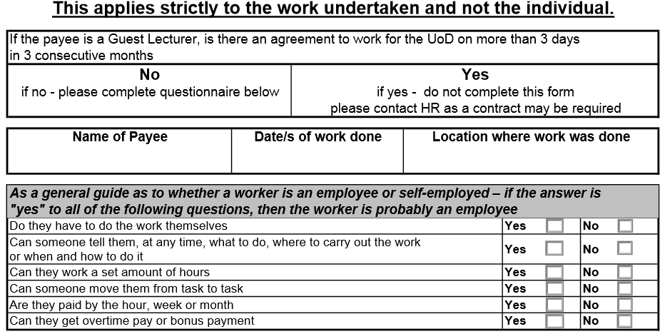

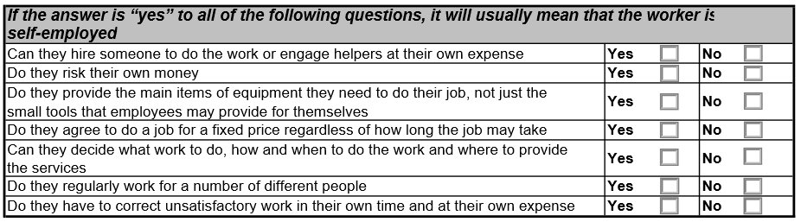

**Please return this form to: - PayrollsDirect, 24 Woodfield Road, Oadby, Leicester, LE2 4HP**

