Employment Application Form (v 1.1)

Please attach recent passport size photograph

For internal use only: To be filled by Geecon

Employee ID Number:
Date of Joining :
Workforce :

- Please provide complete and correct information
- All fields are mandatory
- Please do not use short forms / abbreviations.
Personal Details
Please expand initials in your name -- As the same would be used in our Employment records
Title (Mr./Mrs./Ms.) | First Name |  |  | Middle Name |  | Last Name
 | SUMAN |  |  | SANTOSH |  | THAKUR
Primary Skill / Competency | C,C++,HTML,PYTHON
Source/Channel | Geecon Career Portal / Employee / Candidate / Any other Source
Employee/Candidate Name: AASHISH UPADHYAY …………… Your relation with referral: …FRIEND………………………

Gender: Male Female
Nationality:
Citizenship: INDIAN

If you are not an Indian National, do you have a valid work permit/OCI/PIO to work in India? Yes No
If yes, work permit/PIO/OCI Card valid up-to …………………….(DD/MM/YY)

If no, pl provide reason ……………………………………………………………………………………………………

Date of Birth: 15/03/2001
Place of Birth: BIHAR

Father’s Name: SANTOSH THAKUR
Mother’s Name: NISHA THAKUR

Contact Number/s: 702167079

Personal Email ID: thakursuman321@gmail.com

Alternate Email ID:

Current Address: b/1401,Aims sea view,indralok phase 6,mira road east  Phone Number: 702167079 |  |  |  |  | Permanent Address: b/701,park plaza,queens park ,mira road east  Phone Number: 7021671079
Any Two Relatives Details (Including Name, Address, and Phone Number, Relation, Photo ID proof) |  |  |  |  | Any Two Neighbour Details (Including Name, Address, and Phone Number, Photo ID proof)
Period of Stay (Minimum 3 Years) |  | Current Address |  |  | Permanent Address
 |  | From (month/year) | To  (month/year) |  | From  (month/year) |  | To  (month/year)
 |  | Mar/2020 | Sept/2021 |  | Dec/2009 |  | feb/2020
Preferred Work Location: Bangalore Hyderabad Mumbai Chennai Kolkata Pune

NCR (Delhi/ Gurgaon/ Noida) Any of the above mentioned Locations

If you do not have a Passport, it is recommended that you apply for the same before joining.
Passport Number : P6785453
Passport Expiry Date :17/01/2027

Has your visa ever been rejected Yes No (If yes, please provide the following details)

Reason :

Date of rejection :
For which country :
Permanent Account Number (PAN) : BTAPT0600H

NASSCOM – NSR (National Skills Registry) – IT PIN Number :

Driving License Number : MH0420210018976

Driving License valid up to (mm/dd/yyyy): 14/03/2041

Reference (From your current employer only)
Name and Designation :
Organization :
Relationship :
Address :

Telephone:
Email ID :
Details of prior Employment with Geecon
Have you worked with Geecon before? Yes No

If yes, please mention the period (DD/MM/YYYY): From ___2015_______ To_______2017___

Entity that you worked for BPO Technology Consulting Enterprise: Old Employee ID: ____________

Details on prior interviewing Process with Geecon
Have you applied to Geecon in last 6 months? Yes No

If yes, please mention the period (MM/YY) : ____________________

Previous CID: ____________

Education Details (Please mention all education details starting from highest full time degree obtained)
Qualification with Specialization (Starting from most recent) | Institution Name & City (School/College) | University Name & City / Board Affiliated To | Period  (From – To)  (DD/MM/YYYY) | Student ID / Reg No. | Program  (Part Time / Full Time) | % Marks/ CGPA
Post-Graduation
Graduation | SN COLLEGE OF ARTS,SCIENCE AND COMMERCE / BHYANDER | MUMBAI UNIVERSITY | 2018-21 | 2018016401118144 | FULL TIME | 6.53
HSC/ 12th | THAKUR COLLEGE OF SCIENCE AND COMMERCE / KANDIVALI | HSC | 2017-18 | M081639 | FULL TIME | 56.49%
SSC/ 10th | SEVEN SQUARE ACADEMY / MIRA ROAD | CBSE | 2015-16 | 4116186 | FULL TIME | 8.6
Diploma in Computer Application
State reasons for gap in education (if any) :

Ensure that you are descriptive wherever necessary – e.g. If your previous company is closed down, please do mention it. Telephone Number with specific location code, Employee Code/ ID/ Number is mandatory. If your previous employer did not provide the Employee ID, please mention and state reasons for the same.

Employment details should be of the company you are on payrolls of, not of a company you are deputed to on an assignment with. In case you are showing employments experience in a skill enabling or professional Training institute the same should only be shown if you were on the payrolls of such an institute.

Employment Details - (Please mention all the employments starting from the latest employment)

Note: Verification of your Current Employment would be obtained on or after joining Geecon.

Sl No | Company Name | Address  (Main office & branch where worked) with Company Telephone – Board Line | Employment Type&  Designation/ Position held | Reported to (Name & Position & direct contact number) | Employment Period  From - To  (dd/mm/ yyyy) | Emp Code / Personnel No. / Social Security No.(Mandatory if worked in USA) | Last drawn monthly gross Salary (INR)  &  PF A/C No. | Reasons for leaving | Mode of separation from the organization  (Pls select the below option)
Employer 1 | Geecon systems pvt ltd | Geecon House, Rowhouse 20, Old Golden nest, mira bhayandar, Thane, Maharastra, India, 401107 | Permanent  Contract | Software Engineer | 13/09/2021  To  30/04/2022 |  | Monthly Salary-  2000 | Looking for new learning opportunity | Resignation  Termination  Absconded  Closed Operations  Others(Pls Specify) ………………………...
Employer 1 | Geecon systems pvt ltd |  | Designation | Software Engineer | 13/09/2021  To  30/04/2022 |  | PF A/C No. - | Looking for new learning opportunity
Employer 2 |  |  | Permanent  Contract |  |  |  | Monthly Salary- | Looking for new learning opportunity | Resignation  Termination  Absconded  Closed Operations  Others(Pls Specify)  ………………………...
Employer 2 |  |  | Designation |  |  |  | PF A/C No. - | Looking for new learning opportunity
Employer 3 |  |  | Permanent  Contract |  |  |  | Monthly Salary- |  | Resignation  Termination  Absconded  Closed Operations  Others(Pls Specify)  ………………………...
Employer 3 |  |  | Designation |  |  |  | PF A/C No. -
Employer 4 |  |  | Permanent  Contract |  |  |  | Monthly Salary- |  | Resignation  Termination  Absconded  Closed Operations  Others(Pls Specify)  ………………………...
Employer 4 |  |  | Designation |  |  |  | PF A/C No. -
Additional Information:

Letter of Authorization

To whom it may concern

I agree to provide copies of mark sheets and relevant certificates. I understand that employment with Geecon is governed by Geecon Employment Policies as applicable, including satisfactory information from a background check.

I hereby certify all of the statements made on the Geecon Employee Application Form are true and complete and I understand that omission or misrepresentation of any fact may result in refusal of employment or immediate dismissal.

I hereby authorize Geecon and its representative to verify information provided in my resume and application of employment, and to conduct enquiries as may be necessary, at the company's discretion. I authorize Geecon and its representative to initiate the necessary enquiries/checks with immediate effect; barring my current employment. Verification of my current employment can be initiated on or after the date of joining. I authorize all persons who may have information relevant to this enquiry to disclose it to Geecon or its representative. I release all persons from liability on account of such disclosure.

Signature : 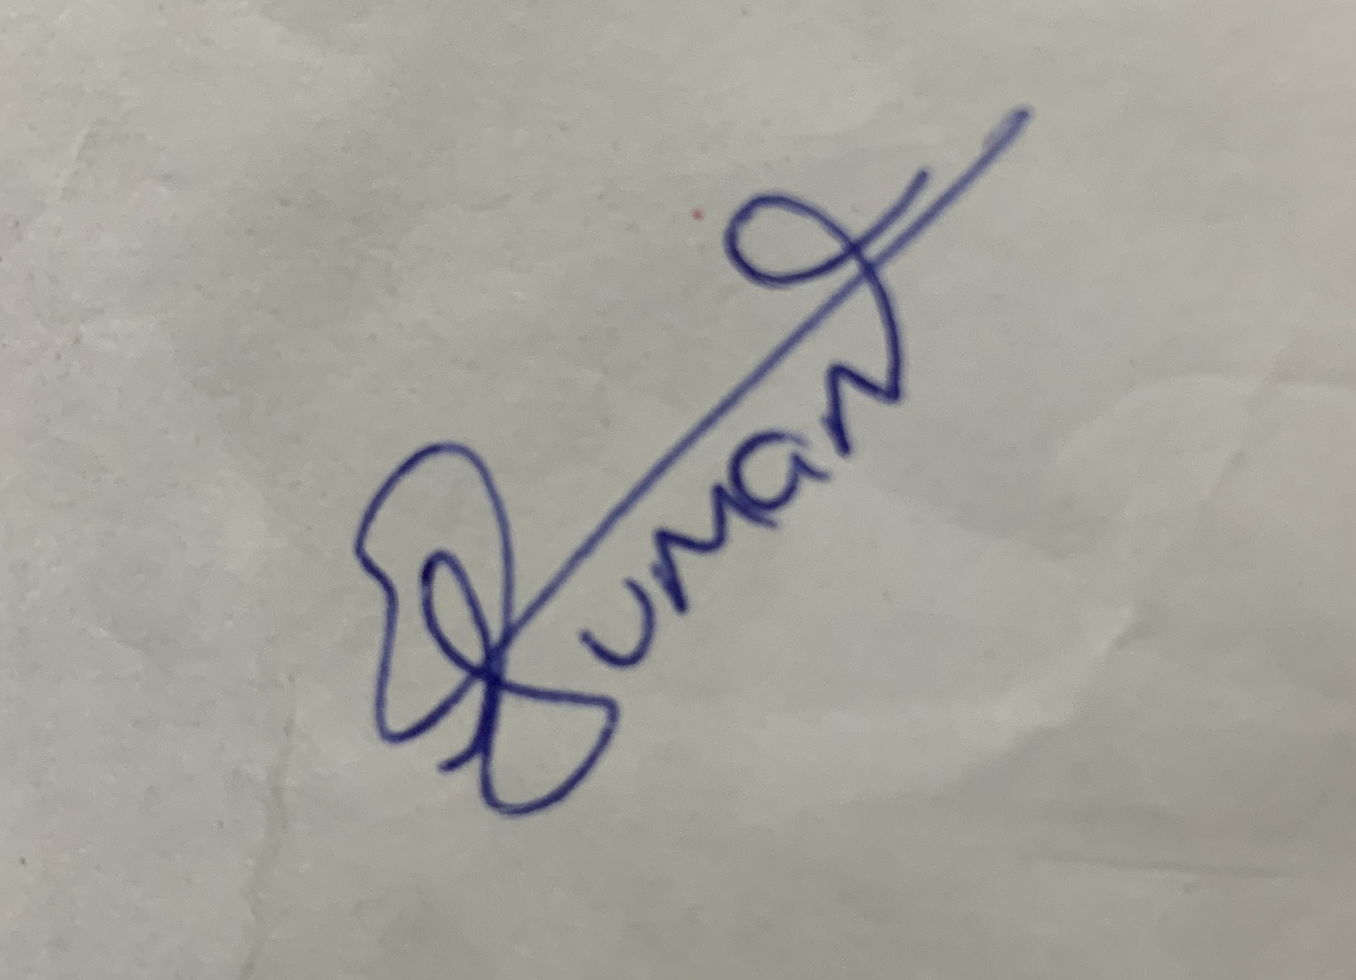

Name in Capitals : SUMAN THAKUR

Date : 11/09/2021

(Please print this page, Sign, mention Name & Date, scan and upload/ share it with the recruitment POC)

