**Module setting**

1. When set no of characters for password as 10 and save and after that refresh page then old value is display that is 8.

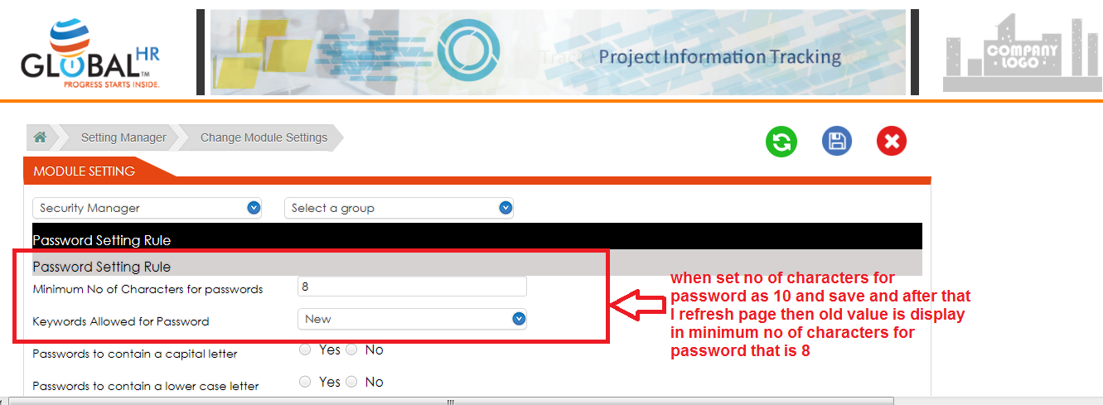

2. It should not have drop down. It should have radio button.

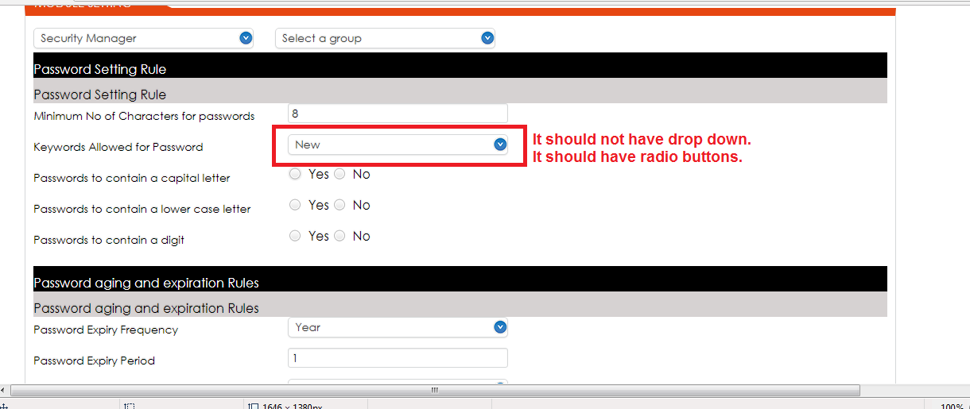

3. Username setting rule are not given on dev environment.

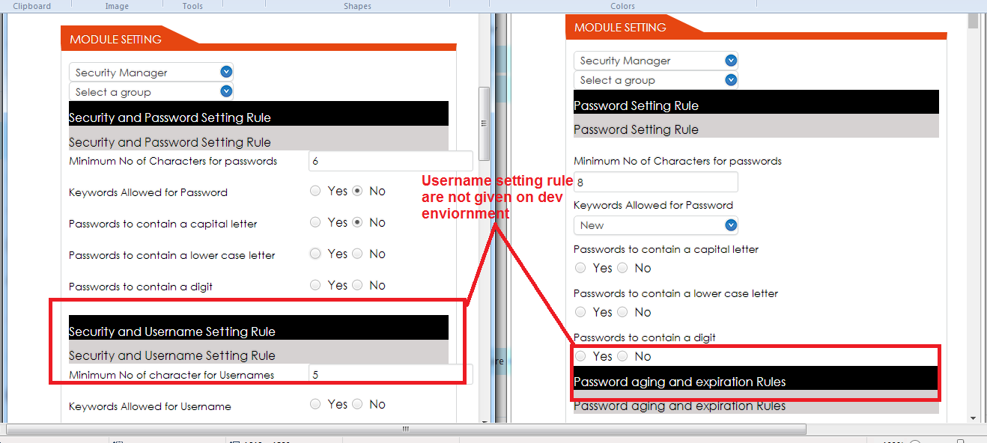

4. UK and Dev environment are same then this rules name should same.

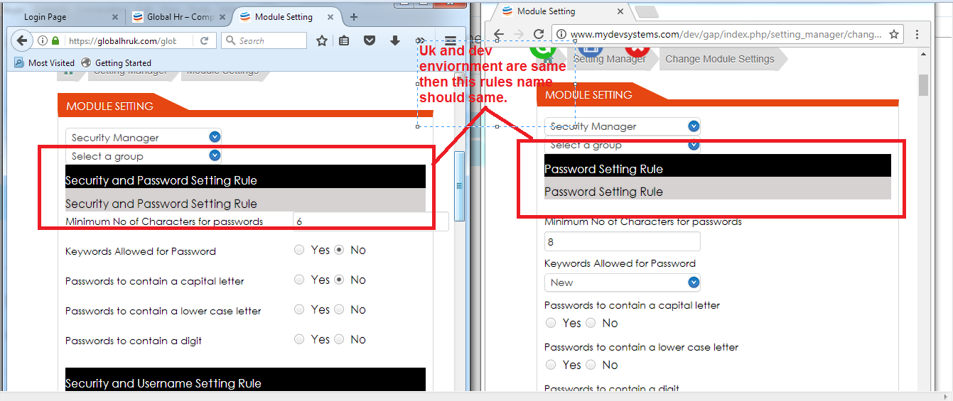

5. Minute also require.

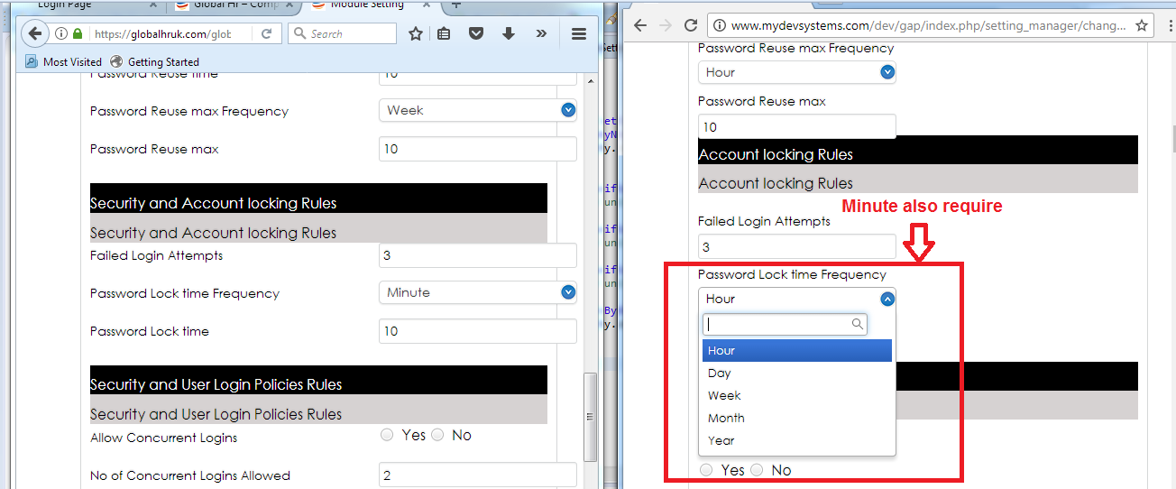

6. No any specification about second level authentication only text displaying.

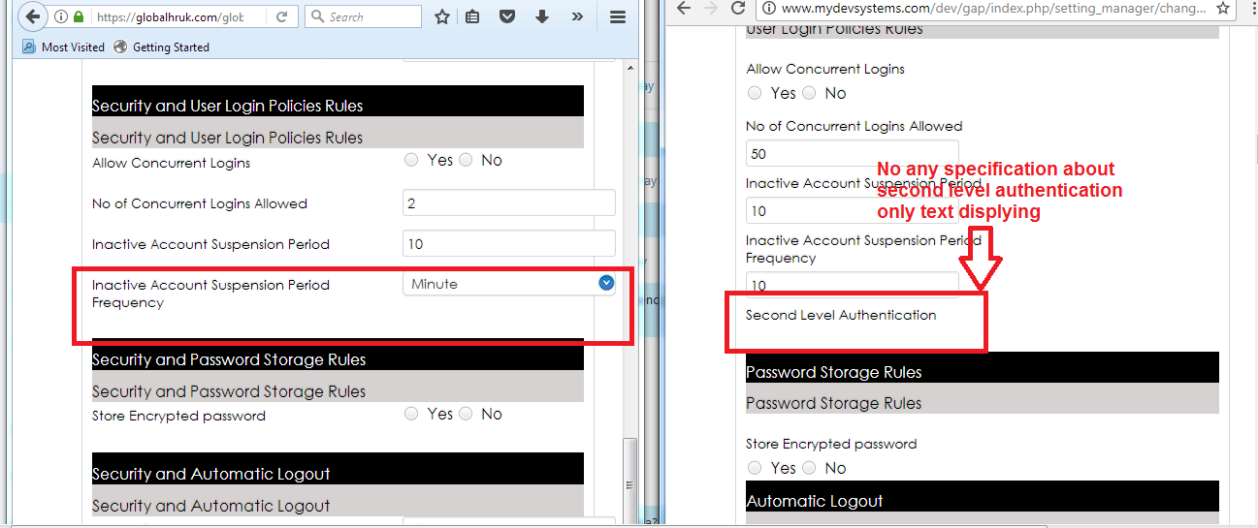

7. Second level authentication not in UK environment under user login policies rules.

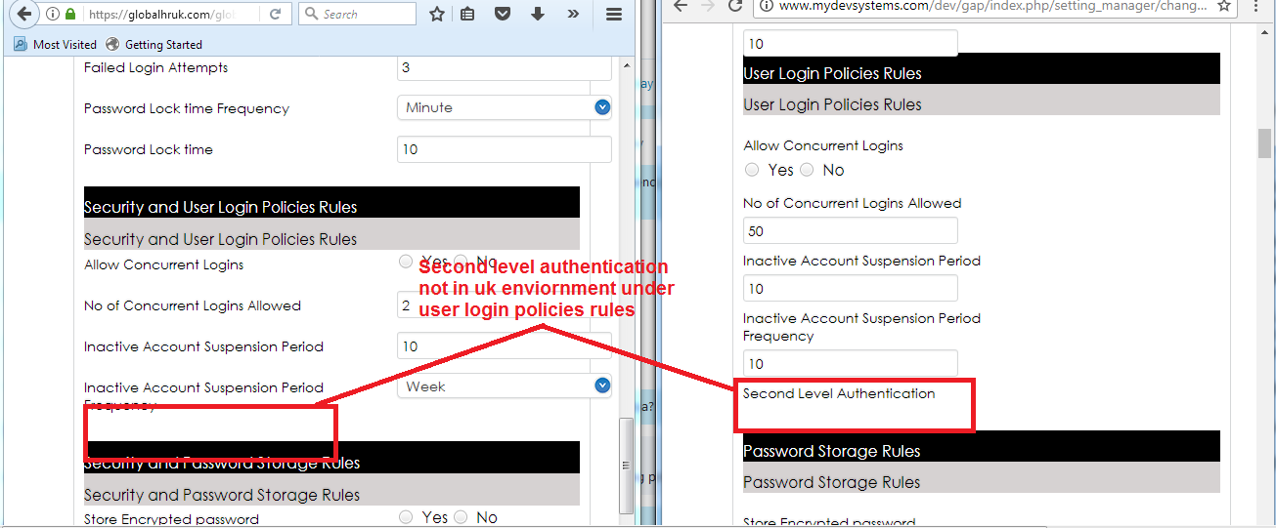

8. After set minimum range of password 10 then password field accepted less than 10 characters. It should not accept.

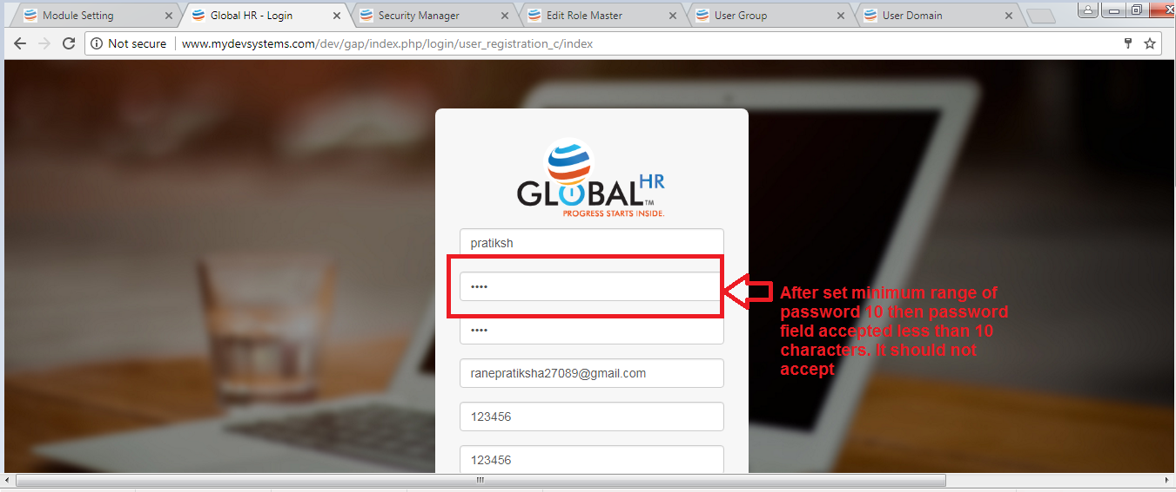

9. set ‘password to contain a capital letter ‘ as No but in password capital letter accepted. This functionality not working properly.

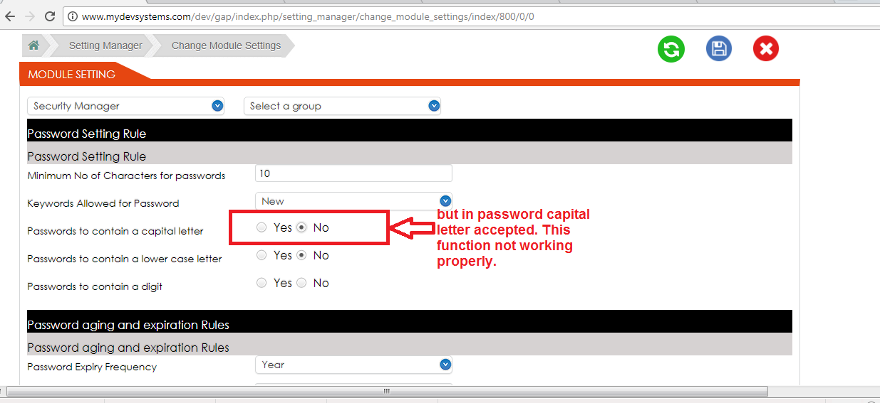

10. After setting password field accepted lowercase letters.

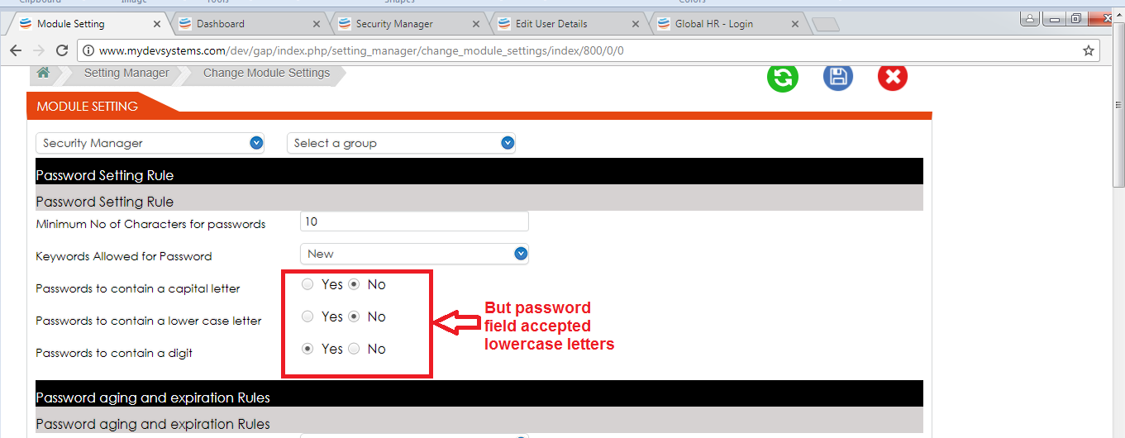

11. after setting for digit ,Password field accepted digit

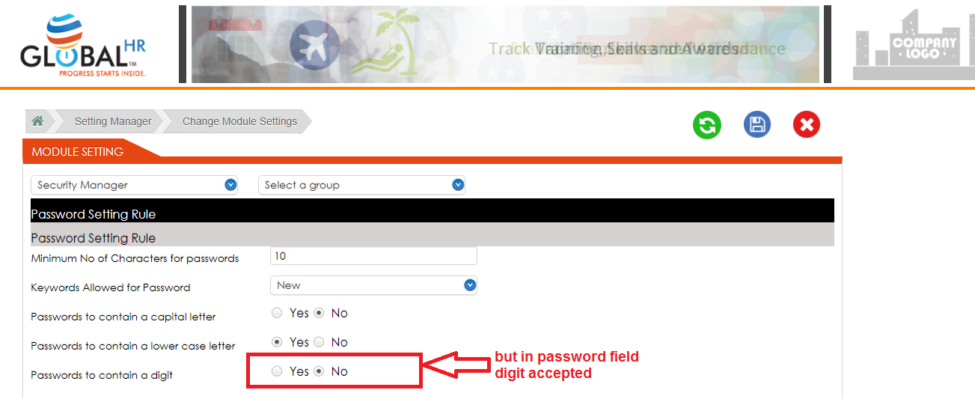

12. Password expiry period field is accepted characters and special character. It should only accept numbers.

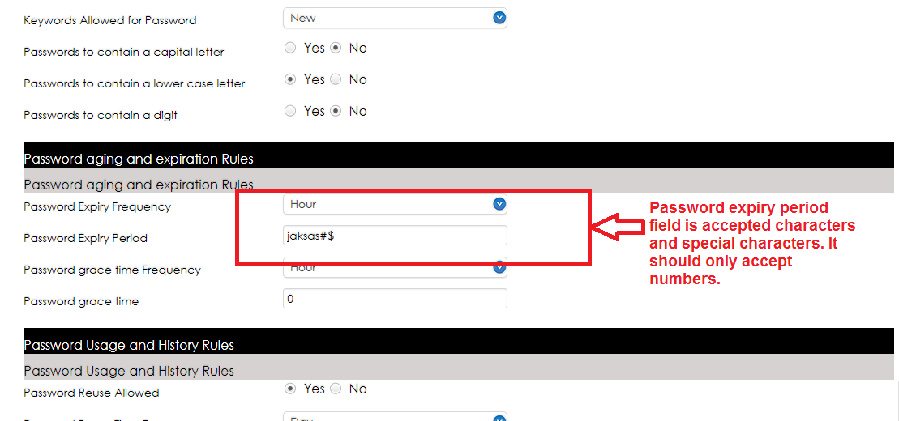

13. When we login 3 times with wrong credential and 3 times login failed after that account should lock. But at 4th time login with correct credential then it logged in successfully.

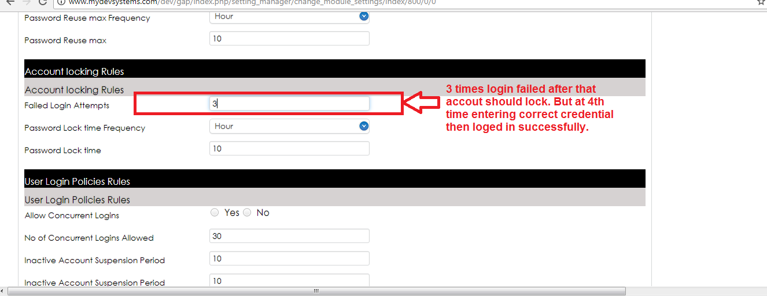

14. When password expiry period set as 1 hour. But after 2-3 hours we are keep login with old password or same password successfully.

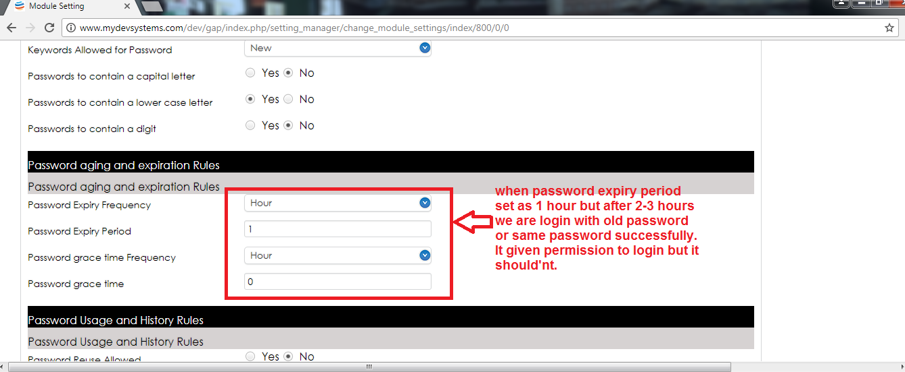

15. When set ‘concurrent logins allowed’ as 1 but when we login with same credential on another system then it logged in.

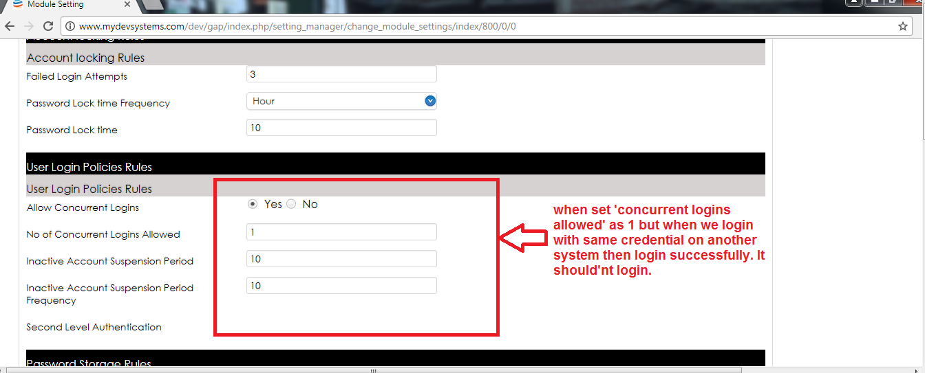

16. Frequency accepted all type of data.

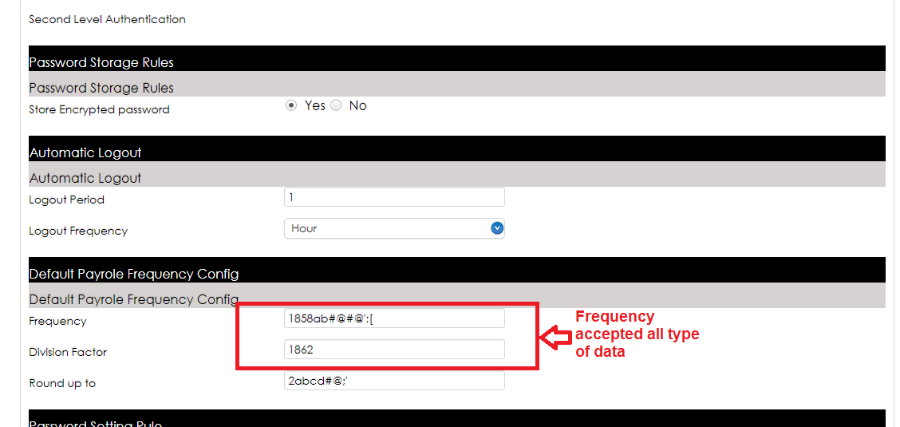

17. Division factor accepted all type of data.

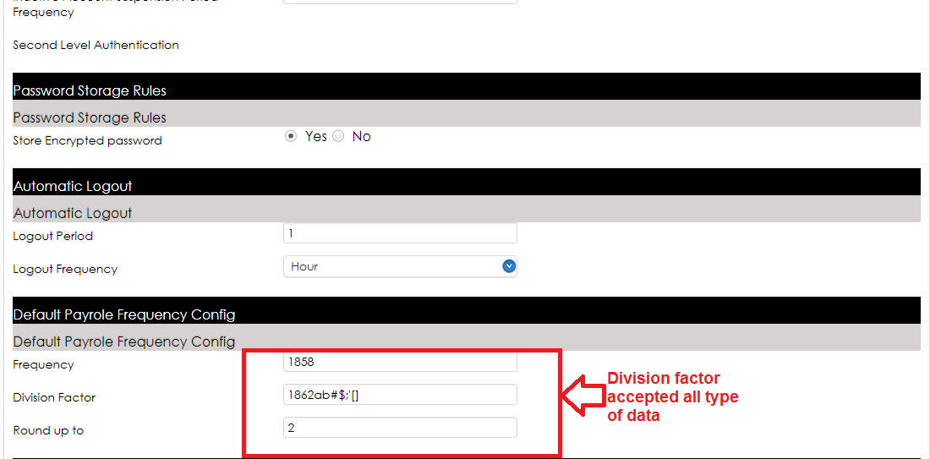

18. Round up to accepted all type of data.

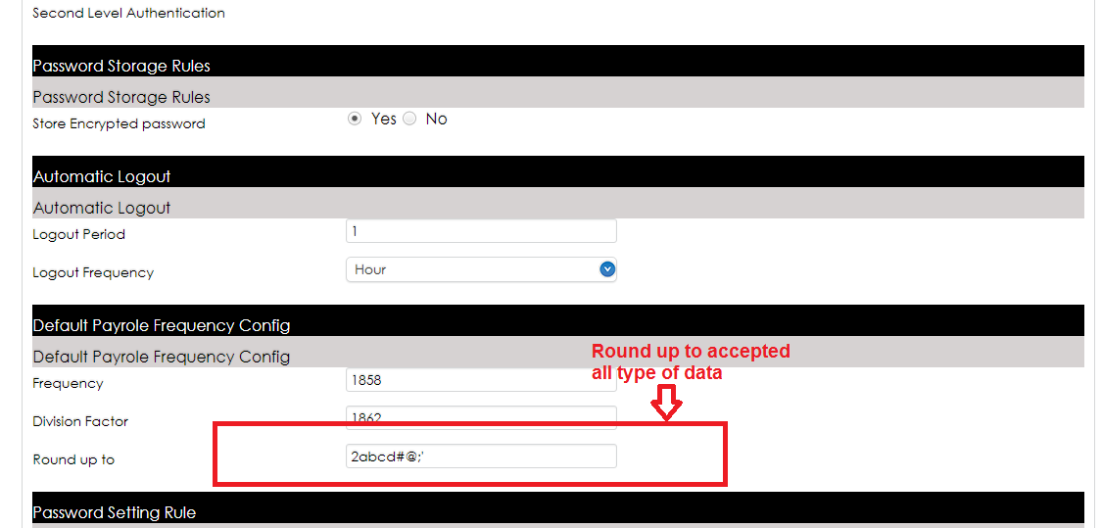

19. This rules for security manager are repeat 4 times.

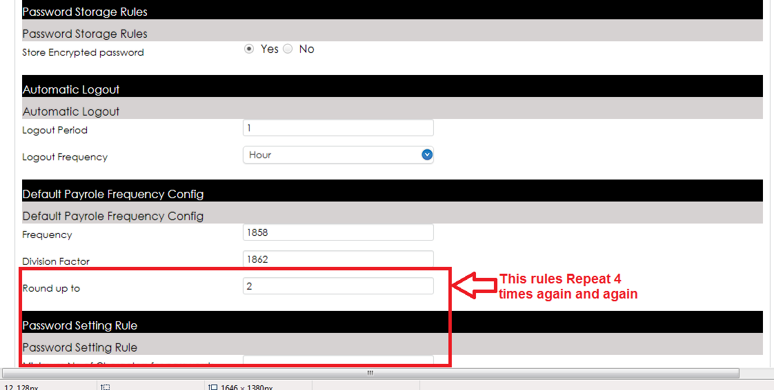

20. Cancel button is not working when we click on cancel button it should close security manager.

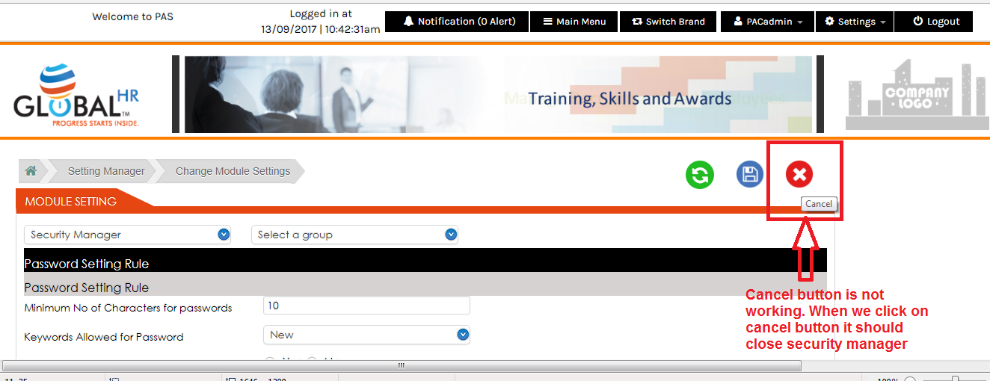

21. Link hover is given only for light blue box on radio button. That’s why radio button is not working properly.

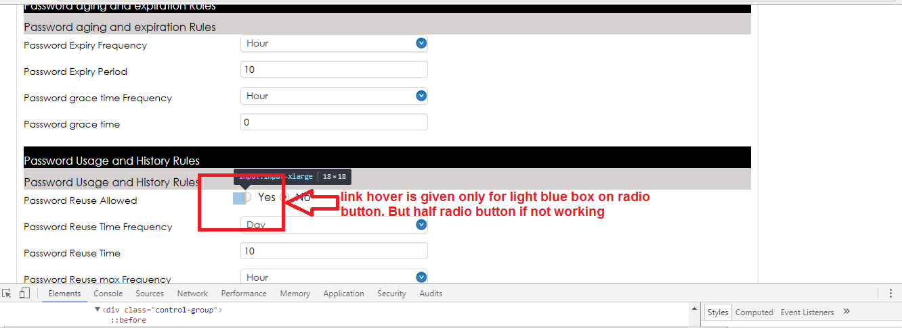

22. After saving not display save confirmation message.

